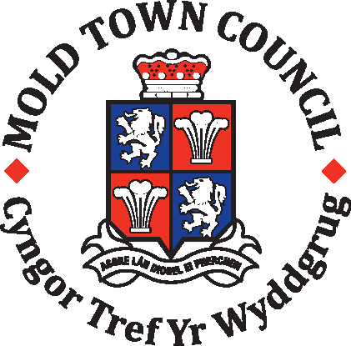MOLD TOWN COUNCIL

Bailey Hill – Group visit booking form

Mold Town Council is the data controller for the personal information provided on this for. Your information will only be used for contacting you with regards to this booking. General information such as name of organisation/ school and number of participants visiting will be used for evaluation purposes and provided to our funders. We will not share your data with third parties unless we are required to do so by law.

Once we have received the completed form a member of staff will be in touch to discuss your booking.

Your Details
Group Name: |  | Name of Group Leader:
Group Leaders Email Address: |  | Group Leaders Contact Number:
Group or Group Leaders Postal Address:

Booking Details
Date of Visit: |  | Length of guided tour:
Time of arrival: |  | Time of departure:
Number of attendees aged under 18: |  | Number of attendees aged over 18:

Additional Information
Please let us know any additional information we need to know to help make your visit as enjoyable as possible i.e. mobility issues.

Emergency Contact Details
Name: |  | Telephone Number:

Office Use Only:

Date booking confirmed: |  | Visitor Volunteers Allocated to session:
Voluntary Donation: |  | Evaluation Form completed:

MOLD TOWN COUNCIL
Bailey Hill – Group visit booking form

Please retain for information.

Venue Address: Bailey Hill Centre, Denbigh Road, Mold, Flintshire CH7 1BL

Charges – We do not charge for guided tours of Bailey Hill although voluntary donations are much appreciated to support the project.

Availability – Guided tours are available Monday to Sunday, please ensure you give us as much notice as possible for your booking.

Disabled Access – Disabled access is available up until the Bailey Hill Centre. Accessibility around the park is limited due to the nature of the site.

Parking Public car parking available in town, nearest to venue is Griffiths Square Car Park. Please use public car park.

Weather: All guided walks are subject to weather. On the day of your visit if the conditions on site are deemed unsafe for the activity to take place we reserve the right to cancel the visit on short notice.

Risk Assessment: The Bailey Hill Project Officer will complete a full Risk Assessment for your visit based on the information you have provided. This risk assessment will be sent to the group leader prior to event. A dynamic risk assessment will also be completed on the day of your visit.

Appropriate Attire: We recommend that all attendees in your group wear sturdy footwear for the visit and dress appropriately for the weather conditions i.e. water proof jacket, gloves, hat, sunscreen etc.

Cancellations: To cancel or amend your booking please email
baileyhill@moldtowncouncil.org.uk or telephone 01352 872418. We would appreciate it if you could give as much notice as possible when cancelling your visit.

Evaluation Form: An evaluation form will be sent to the Group leader after your visit. We are keen to continually improve on the services that we offer, therefore would appreciate it if you could complete and return as soon as possible.

Social Media: We would love to see pictures of your visit with us, please tag us on Facebook: @BaileyHillProjectOfficer or Twitter: @bh_officer

Privacy Notice for Bailey Hill Group Bookings

Mold Town Council is the Data Controller under the new data protection law and will use the information you provide on this form to manage the hire of the Jubilee Room.

The legal basis for processing this data is to process the above contract. Our contact details for any queries is Mold Town Council, 1st Floor, Town Hall, Earl Road, Mold, Flintshire CH7 1AB. We will keep your data for six years. Your information will only be shared with Flintshire County Council.

Individuals have a number of rights under data protection law, including the right to request their information. You also have a right to make a complaint about our handling of your personal data to the Information Commissioner’s Office https://ico.org.uk/

Information you provide will only be used for the stated purpose. Further information about the processing of your data can be found on our website at http://www.moldtowncouncil.org.uk/Mold-land/Default.aspx

If you wish to contact Mold Town Council’s Data Protection Officer you can do so via letter to Ian Jones by post at 1st Floor, Town Hall, Earl Road, Mold, Flintshire CH7 1AB, by email attownclerk@moldtowncouncil.org.uk, or by telephone on 01352 751819.

REQUEST FOR CONSENT:

Please confirm your consent below. You can grant consent to any or all of the purposes listed. You can withdraw or change your consent at any time by contacting the Bailey Hill Project Officer.

We may contact you to keep you informed about what is going on in the Council ‘s area including news, events, meetings and activities. These communications may also sometimes appear on our website, or in printed or electronic form including social media.

We may use your name and photo in our newsletters, or on our website, or our Facebook page.

KEEPING IN TOUCH

Yes please, I would like to receive communications by email.

Yes please, I would like to receive communications by telephone.

Yes please, I would like to receive communications by post.

